Habtom Abadi Import & Export Company profile
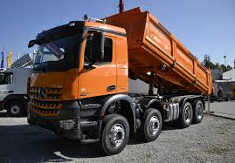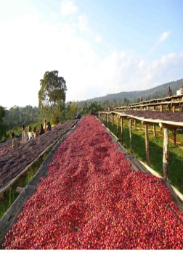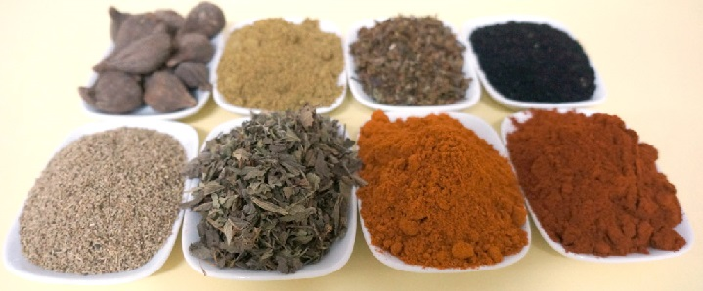
Dump truck coffee species
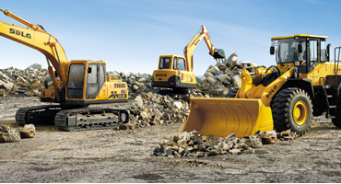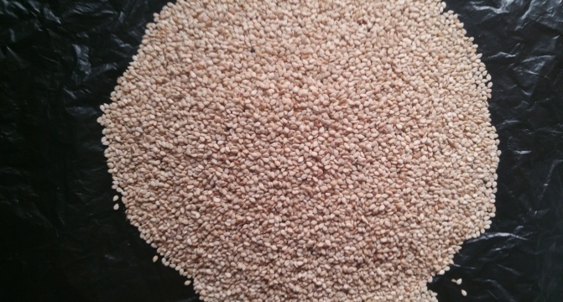
Machineries Oil seed/Sesame Seed

November, 2016
Addis Ababa
Ethiopia

Contents
1. Company profile 2
2. Main objectives of the Company 5
Vision 5
Mission 5
Values 5
Legality 5
3. Core Values and Principles 6
4. Business sector 6
5. Organization and Management 7
6. Staff Profile 8
7. Some of our export products 8
I. Ethiopian Coffee 8
II. Sesame seeds 13
III. Ethiopian Chickpea 14
IV. Ethiopian Linseeds 15
V. Ginger 15
VI. Rape seeds 16
VII. Red kidney beans 16
8. Country export statistics 17
9. Support of Habtom import and Export Company for the suppliers 18
10. TURNOVER GROWTH 19
11. HUMAN RESOURCE 19
12. COUNTRY STRATEGIC FRAMEWORK 19
13. Marketing Strategy and potential customers 20
14. Our Import products with its specification 21
I. 380 HP IVECO HOINGYAN TRUCKS 6*4 22
II. HOWO SINO DUMP TRUCK 24
III. Genleyon (Iveco technology) 24
IV. Iveco Hongyan mixer 25
V. Lower flatbed low bed 26
VI. XCMG Wheel Loader ZL50G 27
VII. XCMG EXCAVATOR XE370CA 28
VIII. XCMG EXCAVATOR XE215C 29
IX. XCMG MOTOR GRADER 29
X. XCMG ROAD ROLLER 30
XI. CANMAX BULLDOZER PD220Y-1 31
XII. XCMG MOTOR GRADER 31

- Background
Habtom Abadi Import & Export initially has been legally incorporated and established in 2000 EC by Ato Berhne Abadi and or Habtom Abadi with Initial Capital of 100,000.00 Ethiopian Birr to engage in export and local trade of Oil seeds, Cerials, pulses and spioces and other agricultural products.

Currently; the company has raised its capital to a largest amount and company has designed the following objectives to meet. The objectives are designed based on the promoter’s existing business and experience to be achieved in the coming three years.

- Export trade on Ethiopian Coffee
- Export Trade on Ethiopian Oil seed; especially Sesame seed
- Export trade on Ethiopian pulses
- Export trade on Ethiopian Spices
- Import trade on dump tracks, Tracker Tracks, Cargo Tracks, and various construction machineries basically based on customer demand.

With the relentless effort of the company owners, management and employees, the company has been performed attractive works and is profitable and growing since its establishment.

- Company profile
Introduction
Being a legally registered company by the Ministry of Trade as per the Ethiopian Trade law, Habtom Abadi Import & Export Company started its operation in 2000 E.C by exporting Ethiopian sesame seed in a small quantities and low level of logistics with an initial capital of 500,000 Ethiopian Birr.
However, by changing challenges into opportunities, the company became nationally competent enough within a short period of time. Currently the quantity of agro-based export commodities(including sesame seeds, Ethiopian Arabica coffee, spices Ethiopian oil seeds, chick peas, linseeds, and others) transacted by the company is growing per annum.
This together with other business services has made the company’s average annual turnover to be very good. Now, Habtom Abadi import and export has come one of the Ethiopian based leading, prestigious and fast developing firms by fully engaged in import, export, and other related business activities including construction machinery sales and transit service. All are discussed in details in this document.
Logistically, the company has own warehouses with average holding capacity which is found at around Kotebe, in front of Kotebe College of Teachers education which is used to facilitate the import business we are engaged in. The company also has own sea same seeds processing warehouses located at 2000 m² Humera. Moreover, the company has a sister company at Gambela named Bealya Agri Development PLC which makes the export activities easy, fast and efficient and allow it to serve our esteemed customers reliably and responsibly.
The organization follows the win- win approach to grow together with our loyal customers and partners by further diversifying our markets, services and commodities. Habtom Abadi import and Export Company has built an excellent reputation in serving its loyal customers responsibly by respecting its commitment.
The human resource potential of our company is fully staffed with highly skilled and committed members. The managers at various levels together with all staff members are aspiring to serve our customers’ loyally, efficiently and responsibly by strengthening their team spirit.

Main objectives of the Company
- Exporting business of different items; Coffee, Oil seeds, Pulses and Spices
- Importing of dam truck, cargo trucks, tracker truck, FSR ISUZU and different types of machineries based n customer basis
- Trading of various commodities
- Distribution to local and international Markets

Vision
To become one of the internationally recognized exporter of Ethiopian Agricultural commodities and leading importer of different types of Tracks and construction machineries.

Mission
Export standard quality of Ethiopian coffee, sesame, pulses, grains and other oil seeds and thereby promote Ethiopian products in the international markets by establishing a partnership with our clients to understand, agree and meet their changing business requirements through our competent workforce and managerial skills. The other mission that has to be mentioned is to provide brand new vehicles and spare parts, assembled vehicles and machines with the motto of quality customer service, and the last but not list is to Contribute for the foreign currency earnings of the country and provide above average returns to the company

Values
- Customer Centered
- Seek to understand and enhance the value our customers.
- Relationship
- We approach our customers and suppliers as equal, long term partners seeking mutual benefit
- Trustworthy
- Under a warm and open atmosphere, we approach our associate & business partners with humility, honesty and enthusiasm.
- Quality: We are committed to produce quality product and service.

Legality
- Name of Company:- Habtom Abadi import and export
- Form of organization:- sole proprietorships
- General Manager: Berhane Abadi
Mob 00251930013444; Email-habtomabadi@gmail.com
- Marketing manager: Alemseged Alemayehu
Mob- 00251932060523; Email-alalemseged@gmail.com
- TIN No. 0004344011; Addis Ababa, Ethiopia

Core Values and Principles

- Creating Satisfied Customers: Our primary responsibility is to our customers and forwards impeccable services and quality products at competitive prices with professional competence and integrity.
- Investing In people: We would be investing in our people in professional development, motivating talent, creating diversity in a team, appreciating effort and rewarding results.
- Reputation and Good Will: being legally responsible and long lasting relationship with stakeholders.
- Driving the Market: Through frequent innovation, creating products with unique selling points and approaches in marketing our products through entertaining promotions.
- Open and transparent management style: We strive to create an empowered management and workforce with a high sense of ownership.
- Learning organization: we are open to accept new ideas since we believe in that there is always better way of doing things. We value most opinion of our customers since they are critical to our success.
- Environmental friendly: we care for the society welfare while doing our business.

Business sector

The main business stream of the company is import and export trade.
- Exporting different Agricultural products
- Construction industry – importing machineries and trucks any other related activities.
- Local trading activities
- Joint venture activities with foreign companies
- Transport activities.
Habtom Abadi import and export company is exporting oil seeds ,pulses, spices and all types of Ethiopian Arabica Green Coffee bean both in the main stream and specialty Sesame seed markets (Israel, Egypt, Sudan, Turkey and the Middle East Countries).
In addition to the listed items above our company also engaged in exporting chick peas, lin seed, rape seed, hops, garlic, soft ginger, horse bean and butyle rubber tube.

Organization and Management
The import and export business line of the company has well structured organization and management system, where all the activities of procurement, processing imports and exports are focused on delivering good and consistent quality coffee, timely execution of contracts and high level customer satisfaction.

GENERAL MANAGER

Secretary

Product, purchasing & Sales division

Administration & Finance Division

Finance Section
Administration

Staff Profile
- The import and export operation of the firm is managed by experienced trader who has longer year experience in the import and export business.
- A person who has more than 15 years of experience in the field also runs the export & Purchase activity of the firm.
- Documentation and shipment follow- up are an important and integral part of import and export marketing. Documents should be performed with utmost care, accuracy, and speed and systematized workflow. Following up the shipment status and providing information to clients is also a crucial task. In this regard, skillful and experienced officers staff our documentation and follow up division.
- More than 15 employees are directly involved in any activities of the company
Habtom Abadi Import and Export business has two section of business
  - The export section business
  - The import section business
Each of the business sections are described in detail bellow.

Some of our export products
Agriculture which accounts more than 50 per cent the national gross domestic product (GDP) is making a significant contribution to Ethiopia’s fast growing economy. The dominant contribution of agriculture as a sector is in turn the result of a combination of various sub-sectors including horticulture and spices. The country is also becoming popular in the international markets for its spice crops. Each of our export products are described below for further information

Ethiopian Coffee
Coffee is the most important agricultural commodity that sustains the livelihood of millions of Ethiopians and brings the largest foreign exchange earnings of the country. Thus among the various business the company specializing, at most attentions is given to the coffee export business.
Ethiopia, which is considered as coffee’s birthplace, produces high-quality Arabica coffee for both the domestic and international markets. Coffee plays a major role in Ethiopia’s economy and is deeply intertwined with cultural traditions and day-to-day living. There are an estimated 15 million people, or approximately 15 percent of the country’s total population, who derive their livelihoods from coffee.
Ethiopia is the single largest African producer of coffee with about half of its production going for export. And, the country is the world’s fifth largest producer after Brazil, Vietnam, Colombia, and Indonesia, accounting for about 4 percent of global coffee production. See Table 1 below for Ethiopia’s contribution to global coffee production.

Around 95 percent of Ethiopia’s coffee production comes from an estimated 4 million smallholder farmers, many of whom live in the southwestern and southeastern parts of the country, grow ‘garden coffee’ on plots of land with an average size of 0.5 hectares. In addition to garden-style production, coffee is produced in other areas, namely forests, semi-forests, and plantations. Yields, with the exception of plantation coffee, remain quite low, 0.7-0.8 metric tons per hectare, but could double with the application of conventional fertilizer. Coffee production is a labor-intensive, manual process in which most farmers employ the support of their immediate family. One of the world’s very top premium gourmet coffees, Ethiopian Coffee is respected for its vibrant, winey acidity along with a distinct pungent wildness and complexity.
Now a day’s globally coffee production and supply is dramatically increasing at international market which leads to high competition. As a result the market demands for high quality coffee. The country has all the potential of meeting the world niche market as most of its product is shaded (for green movements) organic for those that are keen in taking organic products and fair trade coffee that has to be fought for branding. Here is an overview of the fine coffees of Ethiopia along with flavor profiles of these amazing, exotic coffees that are among the best that our company Exports.

Yirgacheffe coffee
The coffees of southern Ethiopia are generally wet processed and these include the very fragrant and spicy Ethiopian Yirgacheffes known for their floral aroma, sweet taste and delicate body. Notes of citrus emanate from the brewed cup. Ethiopian Yirgacheffee Coffee typically has a medium body and exhibits very clean, pleasant and sweet fragrant and spicy flavors and bright acidity. A wet processed coffee, Yirgacheffe is grown at elevations up to 6,600 feet is the most distinguished coffee of southern Ethiopia, an area with many fine coffees
The floral tones in an Ethiopian Yirgacheffe Coffee can be positively complex, sometimes suggesting toasted coconut with wine and berry notes. You may also detect nuances of citrus and tangerine with a tart lemon twist (making it great for iced coffee), and a mild chocolate and nutty flavors.

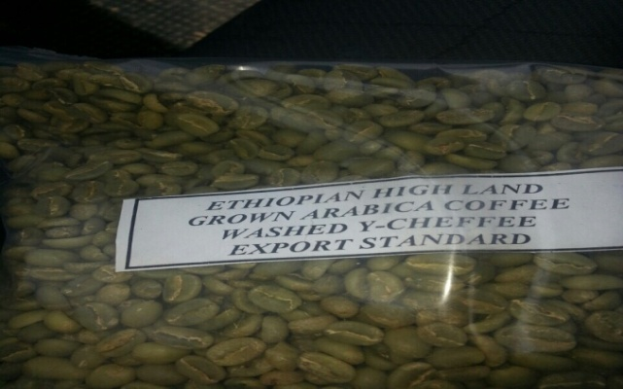

While Ethiopian Harrar Coffees are often considered wild and jammy, the Ethiopian Yirgacheffe coffees instead evoke high-toned citrus and floral notes.

Sidamo coffee
Complex Ethiopian Sidamo coffees also come from this region and exhibit a full, rich body with a bright aftertaste.

Ghimbi coffee
The Ethiopian Ghimbi coffees originate in the western part of Ethiopia and are respected for their sharp acidity as well as complex, rich tastes and aromas.

Harrars coffee
The eastern region of Ethiopia, known for its dry processed are more common in the eastern area of Ethiopia where the winey, fruity Ethiopian Harrars originate providing a complex coffee with a heavy, dry-edged body and notes of blueberry complemented by a brilliant acidity.
The Renowned Ethiopian Harrar Coffees – Best Coffees of Ethiopia. Ethiopian Harrar Coffee is fragrant with a heavy body and spice tones such as cardamom and cinnamon as well as apricot and blueberries, smoke, compote and tones of dark chocolate.
Ethiopian Harrar is a dry-processed exotic and wild Arabica coffee that comes from the small farms of southern Ethiopia’s Oromia area which was formerly known as Harrar, at elevations up to 6,300 feet above sea level. Harrar Coffees Resonate In the Cup – Popular In Espresso Blends
Harrar coffees are known for their fruit and wine tones with floral notes in the acidity making a bright, pleasant cup of brewed coffee. The aroma is quite heady, very pungent and rich, often with notes of blackberries. A fine Harrar has a bold edginess to it and a lasting aftertaste that may seem slightly fermented with intense bursts of jasmine. The fruity quality of Harrar has caused it to be compared to a dry red wine. The bold taste of a fine Ethiopian Harrar is said to resonate in the cup and popular in espresso blends.
Harrar Longberry, Shortberry and Mocha – Best Ethiopian Coffees: The three main Ethiopian Harrar coffees are Longberry which is the largest of the Harrar coffee beans, Shortberry consisting of smaller coffee beans and Mocha comprised of peaberry coffee beans.

Jimma coffee
Ethiopian Djimmah Coffee (also called Jimma Coffee) is cultivated at elevations ranging from 4,400 feet to 6,000 feet above sea level in the Kaffa and Illubabor areas. When this coffee is wet processed it’s very low-acid, though the dry processed Djimmah can produce an unpleasant taste.

Limu coffee
Limu Coffee is cultivated at elevations up to 6,200 feet in Ethiopia’s southwestern region. The brewed cup provides is spicy and winey with a sharp richness, and quite low in acidity yet still vibrant, and with a body that is well-balanced and sweet.
Ethiopian Limu Coffee is a vibrant, wet-processed coffee, very well-balanced with a mild yet somewhat sharp acidity exhibiting floral tones, and fruit-toned spicy and winey tastes. Limu is grown in the south central and southwest regions of Ethiopia at elevations up to 6,200 feet.
Best Coffees of Ethiopia – Harrar, Yirgacheffe, Sidamo and Ghimbi Ethiopian Coffees continued:

Ethiopian Lekempti
Ethiopian Lekempti Coffee is cultivated in the Ghimbi and Wollega areas at elevations up to 5,900 feet above sea level. The brewed Lekempti coffee has a strong body similar to Ethiopian Harrar Longberry coffee along with a fruity taste and a very pleasing acidity.

Ethiopian Sidamo coffee
Ethiopian Sidamo Coffee is a washed (wet-processed) coffee respected for its sweet complexity and floral aroma along with a much muted acidity yet a very full and rich body with tones of chocolate, wine and spice. The aftertaste is soft and bright.

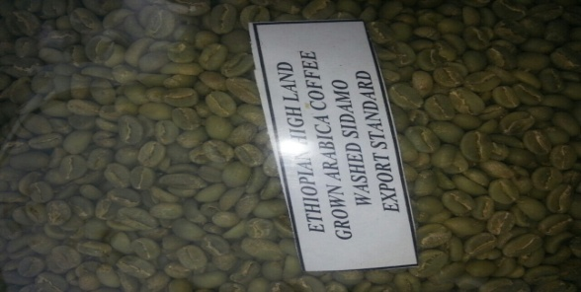
Fig. Sidamo coffee
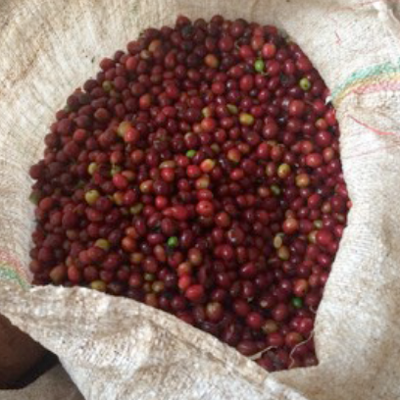

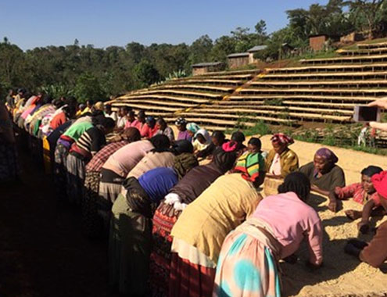
Fig. Coffee under processing
Table 1 Summary of main Ethiopian coffee brands
Ethiopian coffee type | Flavor
Yirgacheffee | Floral
Sidamo | Sweet /spice
Limu | Winey
Lekmpti | Fruity
Teppi | Medium pointed
bebeka | Medium
Harar | Mocha
Jimma | Winey

Table 2: Ethiopia’s Share of the World Coffee Market (1000, 60 kg bag)
 | 2011/12 | 2012/13 |  | 2013/14 |  | 2014/15
Ethiopia’s coffee production | 6,320 |  | 6,325 |  | 6,345 |  | 6,475
World coffee production | 144,040 |  | 153,268 |  | 150,465 |  | 149,800
Ethiopia’s contribution to world market | 4.39% |  | 4.13% |  | 4.16% |  | 4.32%
Source: USDA PS&D for MY11/12-13/14. MY14/15 is post estimate.
Source; Ethiopian Coffee quality inspection center

Sesame seeds
A large number of sesame seed varieties exist in Ethiopia. However, in the international trade, three varieties are well known as trade names: Humera, Gondar and Wellega. The three main export varieties have their own characteristics such as colour, oil content, and taste. Our company product type Humera variety is appreciated worldwide for its aroma and sweet taste. It has good uniform white seeds, which are quite large in size. This makes it very suitable for bakery products. The Gondar type is also suitable for the bakery market. For this market a high level of seed purity is demanded, which has sometimes proven to be problematic for Ethiopia. The major competitive advantage of the Wellega type is its high oil content. Type and quality are very important factors in the world sesame market. According to CSA data, all sesame seed varieties are produced during the main or meher crop season.
Agricultural products have always remained the major exports of Ethiopia. In the year 2015, out of the total export earning of the country, oil crops had a great share of market while the share of sesame for the same year was greater than any. This places sesame as the second foreign exchange earning crop in Ethiopia following coffee. In the last two years also, its sales revenue has shown an increasing trend.
The major producing areas of sesame in Ethiopia are Tigray, Amahra, Oromia and Benshangul Gumuz. However, a small amount of sesame is currently produced in SNNPR. Tigray, Amahra and Oromia have a total share of 92.7% of 2007/08 production. In most of the cases sesame is produced in low land areas of the country where relatively large tracts of arable land is available.
Our company has own sesame seed processing where house at place of products Humera with great capacity of processing and makes things easy for the company to export large quantity.
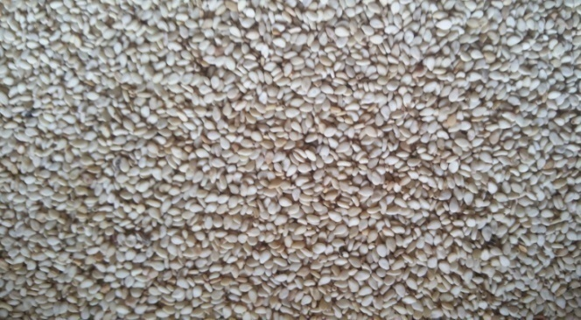
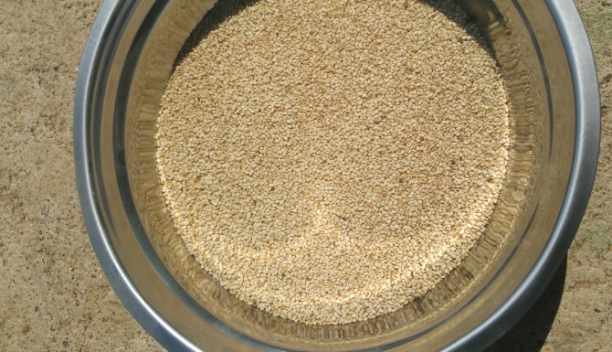
Humera Type Sesame Seed

Ethiopian Chickpea
Chickpea is one of the major pulses grown in Ethiopia, mainly by subsistence farmers under rain fed conditions. It is one of the main annual crops in Ethiopia both in terms of its share of the total cropped pulse area and its role in direct human consumption. Ethiopia is the world’s fifth largest producer of chickpea. Ethiopian chickpea production is expected to continue growing, especially with the increased investments in the chickpea value chain from government and donors.
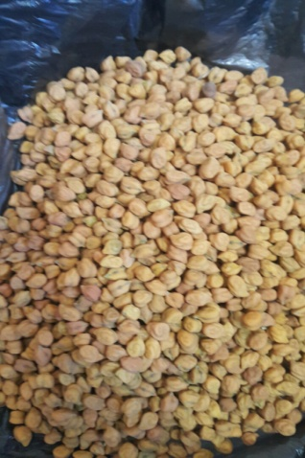
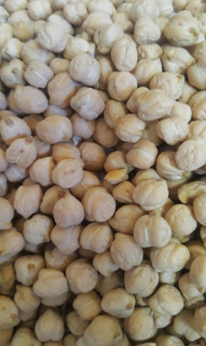
Types of Chickpeas avelable

Ginger
Ginger is one of the spice crops highly produced in Ethiopia. Ginger is not just a widely used ingredient in Ethiopian recipe but also is a source of income for many small-holder farmers. Many describe Ethiopia as suitable for producing the crop in abundance and even for export purposes. Ginger has a long history of medicinal use in the preparation of many Ayurvedic formulations, the traditional medical discipline in India, Nepal, America and Europe.
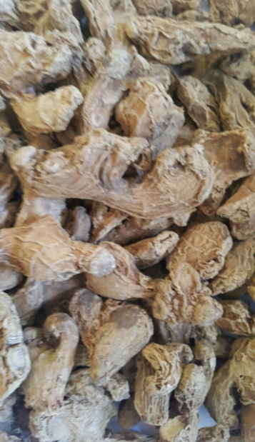
Ginger has pungent taste and interesting aroma. It been used since the ancient times as a spice. In addition, ginger has been used historically for its medicinal value to a wide variety of diseases, especially to gastrointestinal disorders, such as constipation, diarrhea, anorexia, colic, dyspepsia, nausea, vomiting, and motion sickness and remains an important cooking spice around the world.
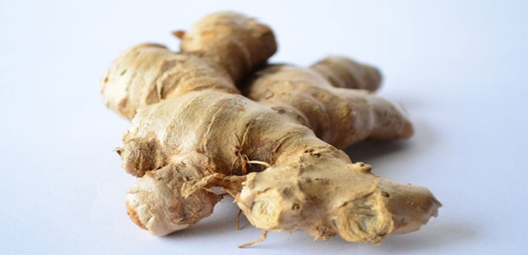
Types of Ginger available In Ethiopia

Rape seeds
There are two types of cultivated species of rape seed namely Ethiopian mustard (Brassica carinata) which is called Gomenzer in Amharic and the exotic rape seed (Brassica napus). Rapeseed thrives best in a soil rich in nitrogen, however it can also be grown in a wide range of soil varying from light to heavy type. In Ethiopia rape seed is mostly cultivated in an altitude ranging from 1800-2600. An area receiving 650 mm of rainfall is suitable for rapeseed production


.

Red kidney beans
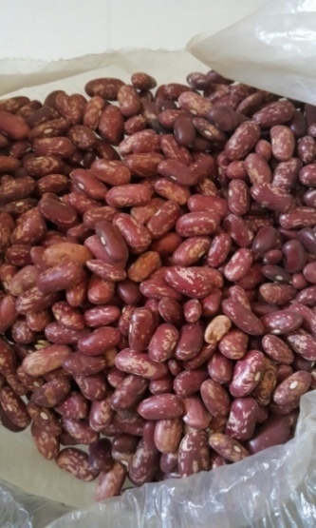
We are among the established manufacturers and exporter of Red Kidney Beans. As name describes this red colored kidney shaped bean is offered in premium grade to our international as well as national customers. Similar to other beans in the family, this bean offer good source of cholesterol lowering fiber. Offered by us, it is also known for offering high fiber content which is helpful reducing blood sugar level. This Red Kidney Beans is procured from trusted vendor to ensure quality.

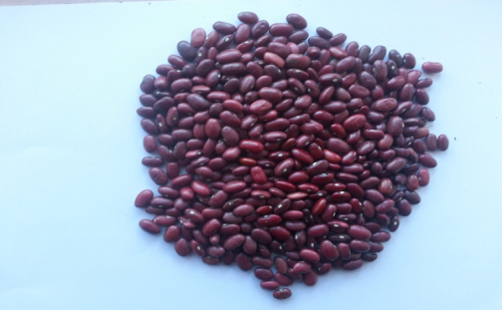

Other Export Items:

In addition to the above items; Ethiopia has various agricultural commodities to export where Habtom Abadsi Import export is engaged. Some of them are the following; Black Cumine, Turmeric and Sunflowers from Spices and white beans, peanuts, Soybeans and Green Mung beans from Pulses.

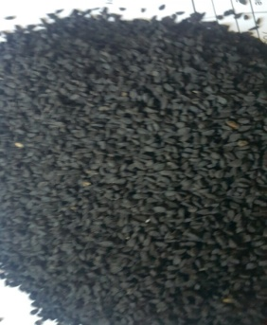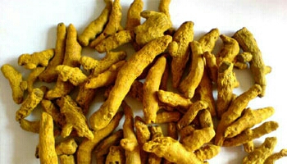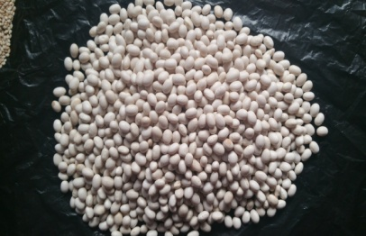
Black Cumine Turmeric White Beans

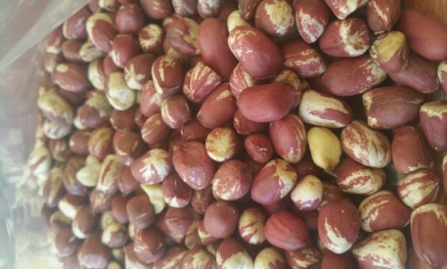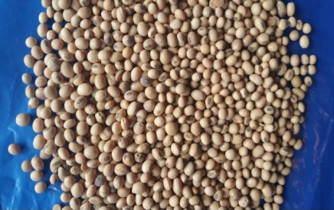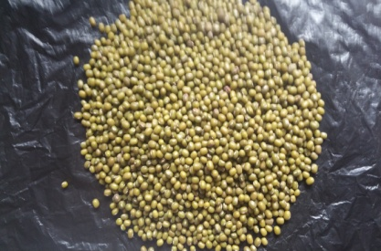
Peanuts Soya beans Mung beans

Country export statistics

Exports from Ethiopia amounted to US$5 billion in 2015, up 92.3% since 2011 but down -11.3% from 2014 to 2015. Ethiopia’s top 10 exports accounted for 92.8% of the overall value of its global shipments.
Based on statistics from the International Monetary Fund’s World Economic Outlook Database, Ethiopia’s total Gross Domestic Product amounted to $170.5 billion in 2015. Therefore, exports accounted for about 2.9% of total Ethiopian economic output.
From a continental perspective, $2.1 billion or 41.8% of Ethiopian exports by value were delivered to Asian countries while 24.2% were sold to European Union members. Ethiopia shipped another 23.2% worth of goods to African importers.
Given Ethiopia’s population of 99.5 million people, its total $5 billion in 2015 exports translates to roughly $51 for every resident in that country. Ethiopia’s unemployment rate was 16.8% in 2015.
The following types of Ethiopian product shipments represent positive net exports or a trade balance surplus. Investopedia defines net exports as the value of a country’s total exports minus the value of its total imports.
In a nutshell, net exports is the amount by which foreign spending on a home country’s goods or services exceeds or lags the home country’s spending on foreign goods or services.
- Coffee, tea and spices: US$1 billion (Up by 17.4% since 2011)
- Vegetables: $837.4 million (Up by 115.4%)
- Live trees and plants: $731 million (Up by 292%)
- Oil seed: $511.5 million (Up by 43.3%)
- Live animals: $324.8 million (Up by 72.4%)
- Gems, precious metals: $168.5 million (Up by 27.9%)
- Meat: $105.3 million (Up by 36.9%)
- Raw hides excluding furskins: $74.3 million (Down by -39.3%)
- Gums, resins: $3.6 million (Down by -65%)
- Other animal-origin products: $1.7 million (Down by -15.1%)
Ethiopia has highly positive net exports in the international trade of coffee. In turn, these cashflows indicate Ethiopia’s strong competitive advantages under the coffee, tea and spices product category.

Support of Habtom import and Export Company for the suppliers
- Technology transfer support by working in collaboration with research institutes in the production, multiplication and dissemination of improved coffee products, chickpea, Lin seeds rape seeds and others to small holder farmers. Support is also provided to private producers and processors who are working on value additions on products.
- Enabling access to finance for infrastructure support through the provision of grants. Our company will enable the arrangement and financial support on construction of the fertilizer blending factory in the country. This is expected to result in significant change towards sustainable supply of inputs with affordable prices for small holder farmers.
- Technical Training Support on improved seeds utilization, post-harvest handling for lead and farmers and to primary cooperatives and union suppliers. The main objective of these trainings is to introduce and enhance the desired skills to farmers as well as cooperative staffs in the production and handling of quality products.
- Reduction of unemployment rate
- Additionally, entrepreneurship training mainly focused on enhancing business knowledge has been part of the training provision to female and youth entrepreneurs in the producing woredas/area

TURNOVER GROWTH
The company has been showing a notable growth for the last years in terms of sales volume, profit, magnitude of business, capital and human resource.

HUMAN RESOURCE

The company has more than 16 well qualified employees and 200 casual labors. More that 52% of the employees have educational level of Diploma and above. This indicates that the company has given due attention to human capital

COUNTRY STRATEGIC FRAMEWORK

Ethiopia‘s overriding development objective is to achieve inclusive, accelerated and sustained economic growth to eradicate poverty. The second five year development plan, the GTP, was launched in late 2015. It is the vehicle for poverty reduction and laying the foundation for structural transformation. The specific objectives of GTP include: (i) maintaining at least 11% average annual growth rate; (ii) expanding and ensuring quality of education and health services and achieve the MDGs; (iii) establishing suitable conditions for sustainable nation-building through creation of a stable democratic and developmental state and; (iv) ensuring growth sustainability by fostering a stable macro-economic framework (v) enhancing the import and export business of the country. The GTP underwent broad stakeholder consultations at national and regional levels.

Ethiopia‘s development efforts under GTP will be pursued through seven strategic pillars. The GTP sees rapid growth as key to achieving the ambitious targets in employment and poverty eradication. Investment in growth-oriented sectors will be expanded.

Agriculture is a key sector in this strategy. The emphasis includes, inter alia, enhancing productivity through scaling up model smallholder farmer practices, the expansion of small and medium scale irrigation, development of rural infrastructure, including all-weather roads and markets, and the promotion of commercial farming. In addition, efforts to conserve natural resources, mitigate and adapt to climate change will be pursued. Higher agricultural productivity is expected to spur industrialization and export growth.

GTP accords priority to the industrial sector, especially small & medium enterprises (SMEs) in order to create employment opportunities for a growing population, especially in the urban areas. In infrastructure, GoE‘s priority is to expand the federal and regional road network and link up all districts (Woredas) with all-weather roads. To address the energy shortfall, renewable energy sources will be further developed and energy infrastructure expanded. GoE‘s target is to install 8,000 Megawatt (MW) in new generation capacity, mainly through hydropower development. This will raise Ethiopia‘s total generation capacity to 10,000 MW to meet domestic demand and allow for export of the surplus.

GTP‘s social development objective is to expand access to education and health services with an emphasis on equity and quality. GoE will continue efforts to deepen good governance and strengthen institutional capacity while paying more attention to gender equality, youth and children. The policies to promote gender equality includeentrepreneurial development, provision of credit, and greater women participation in decision-making and discouraging harmful traditional practices.

Some of the Growth and Transformation Plan Pillars are:
- Sustain rapid and equitable economic growth
- Preserve agriculture as a major source of economic growth;
- Create favorable conditions for industry to play a key role in the economy;
- Infrastructure development;
- Expand provision and quality of social services;
- Build public institutional capacities and deepen good governance; and
- Promote women, ensure youth empowerment and broaden social inclusion.
- Support the import and export business
Source: MoFED. Macroeconomic Policy and Management Directorate

Import and export business is highlighted as one of the best stream in the development of country economy. In support of the development plan, our company will expand the business and contribute its maximum experience for successful accomplishments of the strategy.

Import Marketing Strategy and potential customers

Potential customers of our import business are mostly contractors engaged in physical infrastructural development activities. These include:
- Private local and foreign construction companies;
- Federal and regional governments implementing infrastructure development projects;
- International organizations; and
- Real estate developers.
Provision of quality and dependable services and consistently improving with the changing circumstances are the company's objectives. Accordingly, the proposed Company has the following marketing strategies:
- Undertaking an aggressive market promotion, on a regular basis, of the Company’s business to government and private agencies engaged and/or affiliated with construction activities informing them about available trucks, corporate rates, discount offers, etc.;
- Featuring the services and amenities available at the Company;
- Showing Company’s emphasis on the price/value relationship of the services to be provided;
- Establishing respectful Company reputations by providing quality and genuine services as well as efficient contract administration and company management; and
Exploring working with local firms to establish a competitive amenity packages responsive to specific requirements

Our Import products with its specification

Habtom Abadi import and export has been operational for several years now in the field of import-export trading, dry cargo transport, ware-housing and similar high-level trading activities in the country. Ethiopia is investing billions of dollars every year in infrastructure developments of all economic sectors ranging from agriculture to hydro electric power and from telecommunications to education and other social sectors. This creates ample opportunities for business entities like our company to grow up with the nation and seize the opportunity to contribute its share in the development. Understanding these great opportunities and fill the gap in the supply side especially the country's demand for capital goods, Our Company is established as a private limited company in accordance with Ethiopia’s Commercial Law. To further diversify our services and products and supplement exports, we added dry cargo transport and rental service of rig machines just to mention a few. Our company thus has clearly articulated vision and mission in line with Ethiopia’s endeavor to become one of the middle income nations in the world.
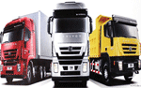

Our importing section imports different Dump Truck vehicles, Construction machinery and equipment and Different ISUZU Vehicle’s. a great demand for construction machineries, dump and cargo trucks, goods and passenger vehicles, and other multipurpose vehicles and equipments. The untapped potential and to contribute own share in the sector, Habtom import and export is established as a full-fledged company to accomplish its missions and objectives. We sale our imported products from available and by order from our customer.

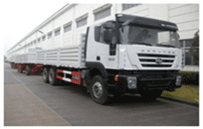
- 371 HP SINO TRUCKS 6*4

    - 371 HP SINO TRUCKS 6*4
BRAND | IVECO- HONGYAN
MODEL | KS3240 (6*4)
SIZEL*W*H | 10185x2484x3090mm
AXEL DISTANCE | 5025+1350mm
Manufacturer :saicfiat hongyan
Engine model: IVECO CURSOR9,EUR3
Emission standard, BOSCH oil pump
4 store direct injection diesel engine
6 stroke direct in-line with water cooling,
MAX output:380hp(280kw)at 2100 rpm according to DIN
Bore*stroke:117mm*135mm
Displacement:8.709LCompression ratio:15.9:1
Engine oil filling quantity:231
Cooling System Filling quantity (long term filling):40L
Ther mosttat opening temperature:80⁰C
Single-cylinder air compressor fan silicone oil
GEAR BOX MODEL | RT11509C
 | Fuller technology faster: 9gear gear box
CLUTCH | Single-plate dry diaphragm spring clutch, diameter 430(b)  mm, hydraulically operating with air assistance
CABIN | Iveco low roof one bed
 | Air speaker, power window, air- suspension seat
 | With original air-condition
 | Color : white
TIRE | 12:00R20
KERB MASS | 3
FRONT AXEL LOAD | 13500kg
REAR AXEL SPEED RATIO | 6500KG
STEERING | 13000 X 2KG
 | 4.8
German ZF changeable speed ratio hydraulic boost imported
Steering
 | 3501 al-mg alloy oil tank
 | Double circuited brake with abs system
 | h900mm, can put 20feet container inside
TRAILER
LORRY OF THE MAIN TRUCK |  | 7500*2484*900MM
MODEL |  | KS41QG
FULL TRAILER PART |  | 9896*2760*2804
AXLE OF FULL TRAILER |  | 13T BPW
TRACTOR HOOK |  | WABCO (USER BOUGHT)
Year of manufacture |  | 2013

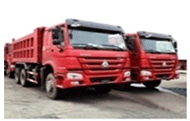
- HOWO SINO DUMP TRUCK
Basic | Made | SINOTRUK
 | Series | HOWO
 | Model | ZZ3257N3647A
 | Driving type | 6X4
Engine | Engine model | WD615.69
 | Engine type | 6-cilinder in-line with water cooling, turbo-charging &  inter cooling, 4-stroke direct injection diesel engine
 | Maximum output | 336 hp (247 kw) at 2200 rpm
 | Displacement | 9.726 L
 | Bore | 126 mm
 | Stroke | 130 mm
 | Compression ratio | 29.8 hp/l
 | Specific fuel consumption | 195g/k wh
Transmission | Model | Hw15710(fuller technology)
 | Speeds | 10 speed
Steering | Model | Zf power stering, model zf 8098, hydraulic steering
Tire | Radial tire | 12.00R20
Dimensions  mm | Wheel base | 3600+1350
 | Overall dimensions | 8145*2496*3386
 | Dimension of the rear dump body | 5400*2300*1400(16M³)
Performance | Maximum driving speed (km/h) | 75
 | Maximum grade ability (%) | 40
 | Minimum ground clearance (mm) | 314
 | Minimum turning circle (m) | 20
 | Fuel consumption (1/100
Year of Manufacture |  | 2013

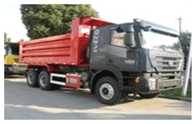
- Genleyon (Iveco technology)
Chassis Model | CQ3254HTG384L.,6x4 Dump Chassis
Description | GENLEYON (IVECO TECHNOLOGY)6X4 DUMP TRUCK MY  2013 MODEL CQ3254HTG384 EMISION STANDARD EUROIII  ORIGIN CHINA HS CODE 87041000
Vehicle main dimension | Overall dimension(LxWxH)mm | 8475×2500×3350
 | wheel base(mm) | 3825+1350
 | wheel track(front/rear)(mm) | 2006/1850/1850
 | Overhang(front/rear)(mm) | 1435/1865
 | Approach/Departure angle | 23/20
Weight in KGS | GVW | 25000
 | Curb weight | 12090
 | Loading capacity | 25000
 | Front axles loading capacity | VL4/15D-7.5
 | Rear axles loading capacity | HL7/015DS-13
Max driving speed(km/h) | 90
Engine | Brand | SFH
 | Model | F2CE0681B*B052(C9380)
 | Type | Inline six-cylinder, water-cooled,  four stroke, turbocharged and intercooled, electronically controlled fuel injection  pump fuel supply rate
 | (PS)KW | (380)280
Year of manufacture |  | 2013

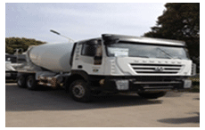
- Iveco Hongyan mixer
DESCTIPTION
Iveco -Hongyan mixer
Brand | HONGYAN GELYON
Type | Mixer Turk
Model | CQ5253HTGB384 (DRIVER FORMS 6x4)
Dimension : Length*width*Height | 9125*2500*3950mm
Engine | IVECO CURSOR-9 380HP
Gear Box | Rt11509C
Steering | Zf technology full hydraulic power assisted
Clutch | 420mm type single plate power boosted
CAB | IVECO GELYON FLAT TOP CABIN
Max speed | 90 km/h
G.V.W | 33110kg
Laden Mass | 20000 kg
Empty Weight | 12980 Kg
Front ax | 6500 kg
Rear axle load | Hongyan full cast reinforcement double reduce rear axle, no welding. 16000kgX2 kg
Rear axle gear rate | 5.73:1
Fuel type | Diesel
Exhaust standard | Euro 3
Number of axle | 3
Wheel base | 3825 + 1350mm
Number of suspension spring | 9/12
Number of tires | 10 + 1
Type of tire | 12.000-R20
Agitator tank effective volume | 8 Cubic miter
Longitudinal beam | 8mm + 8mm, Two 317mm

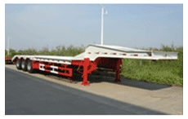
- Lower flatbed low bed

DESCRIPTION
Low bed
Type | Lower flatbed low bed
Model | Ks9407dTP
Year of manufacture | 2011
Maker | Kunshan special vehicle manufacture company
Capacity (kg) | 45,000 – 55,000
Kingpin height (mm) | 1,450 to suit the truck
Overall length (mm) | 12,800
Overall width (mm) | 3,000
Overall height (mm) | 3,050
Empty weight | 12,000
G.V.W (kg) | 57,500
Total axle load (mm) | 36,000 (12,000 x 3) BPW axle, 12 BPM
Wheel base (mm) | 7,860 + 1300 + 1300
Tire | 12:00 – 20 18
structure | All steel welded construction, Chinese steel standard Q345 6mm chequered plate on C profile raves
Floor | 6mm chequered plate on C profile raves
Chassis | Two longitudinal 500mm I beams (16mm upper; 10mm middle and 18mm bottom) with cross number reinforcement, Chinese steel standard Q345.
Axle/ suspension | BPW axles with 16mm 8 leafs suspension 12 BPW, 16mm
Break | Two line drum brakes acting on all wheels with S cam actuation, two single acting diaphragm brake chambers.
Landing gear | Two JOST heavy duty legs with static load 40 ton, and lifting 25ton. JOST 40
Kingpin | JOST 2’ kingpin and 3.5 king pin JOSP 2
Electric system | 24V, 7 ways quick coupler and side and rear lights 24
Accessories | Side and bumper reflecting sings, a tool box, one spare tire, side crush guards, 12 rope hook and winches.
finishing | Grit blasted anti corrosion prime and high glossy white

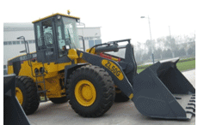
- XCMG Wheel Loader ZL50G
PRODUCT NAME&MODEL | CONFIGURATION
XCMG Wheel Loader ZL50G | Engine model: SC11CB220G2B1
 | Rated power:162Kw
 | Rated load: 5.0t
 | Bucket Capacity: 3 m3
 | Min turning radius:6400mm
 | XCMG planetary box, XCMG axle,air condition and pilot control.
 | Dimensions:8110×3000×3508mm
 | Operating weight:18t
 | Packing: 1 set will be fixed in one 40'HQ
Option | Rock bucket

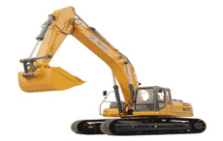
- XCMG EXCAVATOR XE370CA
XCMG Excavator XE370CA | Engine :ISUZU AA-6HK1XQP
 | Rated power:190.5/2000kw/r/min
 | Bucket capacity:1.4-1.8m3
 | Bucket digging force at max: 242KN
 | Max digging height: 10123mm
 | Max digging depth: 6927mm
 | Operating weight:36600kg
 | Overall dimension: 11386*3190*3530mm
Optional | Hydraulic pipeline and Gongbing Hydraulic hammer

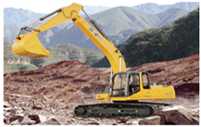
- XCMG EXCAVATOR XE215C
XCMG  Excavator  XE215C | Diesel Model : ISUZU BB-6BG1TRP
 | Power:106.5/1950KW/rpm
 | Operating Mass: 21,450 kg
 | Bucket capacity:0.91m3
 | Max digging height: 9640mm
 | Max dumping height: 6800mm
 | Overall Dimension: 9525x2990x3000mm
Optional | Hydraulic pipeline and hydraulic hammer

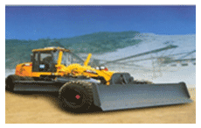
- XCMG MOTOR GRADER
Model |  |  | GR215
Main parameter | Engine Type |  | Cummins 6CT8.3-C215
 | Rated power/rotating speed KW/rpm |  | 160/2200
 | Overall dimension (LXWXH)mm |  | 9422 x 2601 x 3430
 | Weight/kg |  | 17000
Performance parameter | Forward speed km/h |  | 5, 8, 11, 19, 23, 38
 | Draw back speed km/h |  | 5, 11,23
 | Traction KN |  | 87
 | Max. slope of climbing % |  | 20%
 | Tyre inflation pressure Kpa |  | 260
 | Working system pressure Mpa |  | 18
 | Transmission pressure Mpa |  | 1.3-1.8
Working parameter | Max steering angle of Front wheel |  | + 45⁰
 | Max inclination angle of Front wheel |  | +17⁰
 | Max swinging angle of Front tyre |  | +15⁰
 | Max steering angle of Balance case |  | +15⁰
 | Max steering angle of frame |  | +27⁰
 | Minium turning radius m |  | 7.8
 | Bucket force | Max. Hoisting height mm | 460
 |  | Max bucketing thickness mm | 500
 |  | Max inflation angle | 90⁰
 |  | Cutting angle | 28⁰ -70⁰
 |  | Circle reversing rotation | 360⁰
 |  | Length and chord height mm | 4270 x

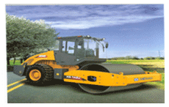
- XCMG ROAD ROLLER
model |  | XS142J
Mass Specification | Operating weight kg | 14000
 | Weight on front drum kg | 7000
 | Static linear pressure N/cm | 322
Main Dimension | Outside Dimension (L x W x H) mm | 6010 x 2350 x 3160
Speed range km/h | Speed I | 2.7
 | Speed II | 4.8
 | Speed III | 10.5
Main performance | Theoretical gradeability % | 30
 | Min. external turning radius mm | 6800
 | Steering angle | + 30
 | Oscillating angle | + 11
 | Vibration frequency Hz | 28
 | Nominal amplitude (high/low) mm | 1.9/0.95
 | Excitation force (high/low amplitude) kN | 274/137
Engine | Model | SC5D125G2B1
 | Type | Water cooled, pressurized
 | Max. power kW | 92@2200r/min
 | Oil consumption g/kw.h | 230
Oil Mass | Hydraulic oil tank capacity L | 170
 | Fuel tank capacity L | 180

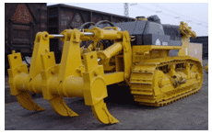
- CANMAX BULLDOZER PD220Y-1
Canmax  Bulldozer PD220Y-1 | Cummins NTA855-C280S10
 | Rated power:162kw
 | Semi- U blade:4130*1590mm
 | Track width:560mm
 | Dimension:7095*3725*3575mm
 | Self weight:25500kg
Optional parts | Single shank
 | Triple shank


- XCMG MOTOR GRADER
Model |  |  | GR215
Main parameter | Engine Type |  | Cummins 6CT8.3-C215
 | Rated power/rotating speed KW/rpm |  | 160/2200
 | Overall dimension (LXWXH)mm |  | 9422 x 2601 x 3430
 | Weight/kg |  | 17000
Performance parameter | Forward speed km/h |  | 5, 8, 11, 19, 23, 38
 | Draw back speed km/h |  | 5, 11,23
 | Traction KN |  | 87
 | Max. slope of climbing % |  | 20%
 | Tyre inflation pressure Kpa |  | 260
 | Working system pressure Mpa |  | 18
 | Transmission pressure Mpa |  | 1.3-1.8
Working parameter | Max steering angle of Front wheel |  | + 45⁰
 | Max inclination angle of Front wheel |  | +17⁰
 | Max swinging angle of Front tyre |  | +15⁰
 | Max steering angle of Balance case |  | +15⁰
 | Max steering angle of frame |  | +27⁰
 | Minium turning radius m |  | 7.8
 | Bucket forcE | Max. Hoisting height mm | 460
 |  | Max bucketing thickness mm | 500
 |  | Max inflation angle | 90⁰
 |  | Cutting angle | 28⁰ -70⁰
 |  | Circle reversing rotation | 360⁰
 |  | Length and chord height mm | 4270 x 610

